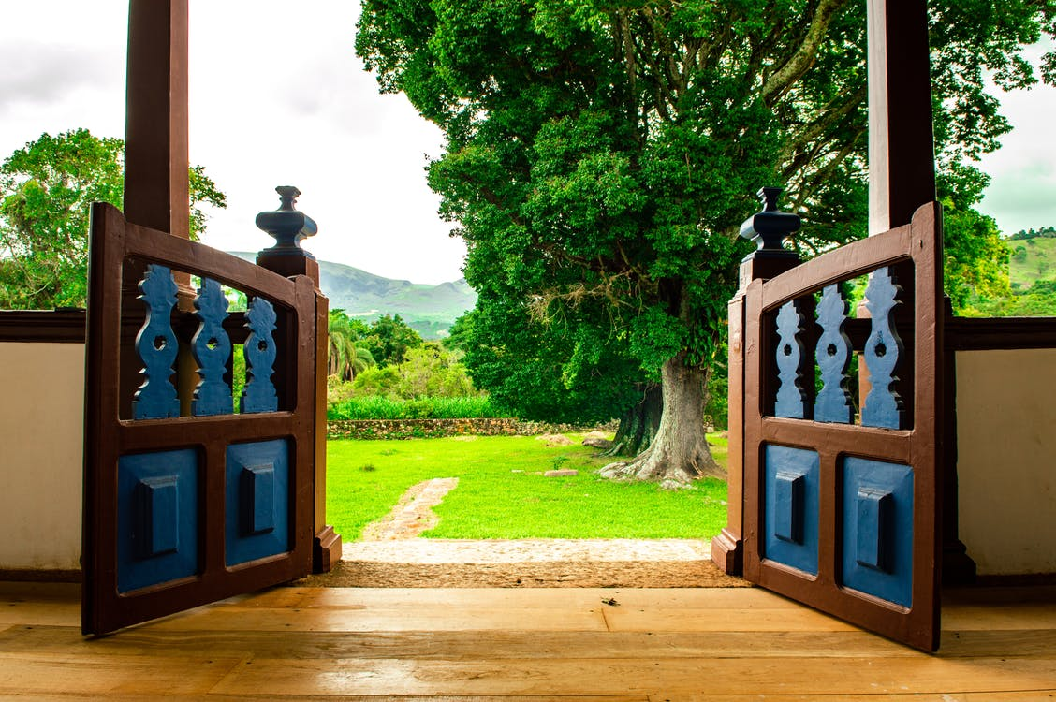

How to Achieve Your Dream of Obtaining a Bigger Home Even as You Retire

Buying a new, larger home can be an exciting project if you’re planning to use your new home for more than just the sole purpose of living there. For example, you may be a retiree who is looking for that extra bit of land to launch your new homesteading hobby or to welcome the whole family there from time to time to enjoy the fresh air and the natural scenery around them. So, if that’s you, and you’re looking for a bigger place to not only call home but to do exciting projects on, here are tips from Kimberly Lane Properties on how to obtain the perfect home.

Establish what you are able to afford
Certainly, you’ll need to establish a budget that will take into account a larger mortgage that comes with owning a bigger property. Furthermore, you’ll need to take into account additional expenses such as homeowner’s insurance or any property taxes that may be applicable such as PITI, for example. But this is probably a task where two heads will be better than one when it comes to choosing the right home loan for you and your budget. So, don’t hesitate to rely on the advice of a seasoned financial advisor if numbers aren’t your forte. But you can also do some of the research yourself so that you at least have a rough idea of what you’ll need to plan for financially by making use of the various budgeting tools that are available to use online.

Suppose that you still must sell your existing property to be able to purchase your new one and these two timelines are clashing somewhat because you’re still holding out for the best price for your current home. Then you could always request an extended closing to buy you the additional time you need to get the best price for your home.

Figuring out the size of property you’ll need
The size of your property is going to matter a great deal, especially if you are planning to launch a homestead business from home. Moreover, it’ll probably be the size of your land that is going to be a deciding factor if you intend to use the land for self-sustaining purposes. While a realtor can assist you with finding the ideal property to accommodate your family and extended family on a regular basis, an appraiser can help you determine what the ideal square footage of your home should be if you plan on using the land to farm, for example.

Starting a business
Perhaps, you’re well on your way to establishing a business from home, but you need the added assurance that you’re headed in the right direction, then a business plan is an excellent tool to have at your disposal to ensure you’re headed on the right path. Be sure, though, to include the most relevant information about your business so that you have it all on record to refer back to when you need to. For example, details that you don’t want to leave out include what type of structure your business will have, what type of business you’ll be starting up, any licenses or permits you may require to do so, what your marketing and financial plans are going to look like including how you intend to raise your startup capital to get your business off the ground and what your financial projections are likely to be going forward.

This much is true; finding your ideal property, even if it is later in life, is entirely possible to do if you are determined to make it happen. And you have the financial and moral support to see your decision through to the end. Then you’re sure to find a property that you’ll be happy with, and your family will certainly feel the same way too. And remember to work with Kimberly Lane Properties to make the search for your dream home that much easier.

Image via Pexels

